Proposed Devon Data Campus and Battery Storage Site
Many constituents will already be aware of the emerging proposal from Xlinks for a large-scale AI data centre campus and Battery Energy Storage System (BESS) between Great Torrington, Weare Giffard and Huntshaw.
According to information released by the developer, the project would occupy approximately 850 acres, with large data-centre warehouses 40m tall, extensive battery storage infrastructure (2,700 shipping containers) and associated facilities.
Community Concerns
Significant concerns have been raised by residents and local organisations regarding:
- Loss of productive agricultural land.
- Landscape and visual impact.
- Effects on biodiversity.
- Energy demand and grid capacity.
- Water usage.
- Public health concerns arising from noise and heat.
- Traffic impacts during construction and operation.
- The scale of development within a rural landscape and UNESCO Biosphere area.
Current Position
Importantly:
- No planning application has yet been submitted.
- Separate applications are expected for the data centre (outline planning) and battery storage facility (full planning).
- Public consultation events originally planned for July have been postponed by Xlinks and we are awaiting dates for further engagement.

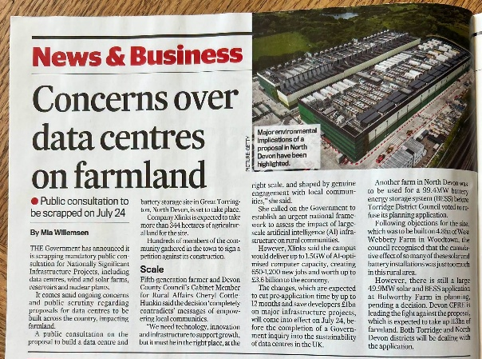
My Position
I have been advised by some that, as a district and county councillor, I should remain neutral and sit on the fence until further information becomes available. However, having learned more about existing data centres and being told the scale of the proposal, I quickly came to the conclusion that I could not remain silent.
I am hugely concerned by what is being proposed and in my view, we already know enough to conclude that this is the wrong development in the wrong place.
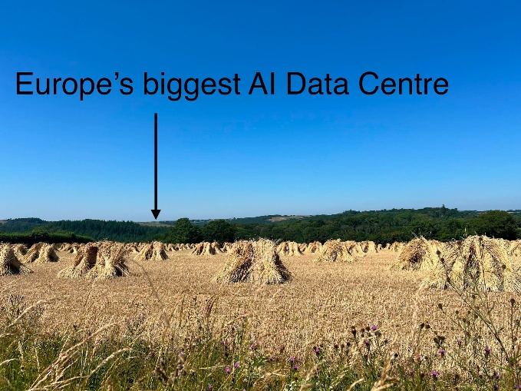
The scale of this proposal cannot be overstated. If approved, the Devon Data Centre would be the biggest data centre development in Europe, alongside what would also be one of the largest Battery Energy Storage Systems (BESS) in the world. This is a proposal of unprecedented scale for rural Devon and is difficult to even comprehend, It is bigger than the town of Great Torrington.
The proposal would remove 850 acres of productive agricultural land within a UNESCO Biosphere landscape. It includes areas of historic significance, including listed farmhouses, important wildlife habitats and land that contributes to our food security.
If a development of this scale can be built here, then it opens the door for similar developments almost anywhere in the country.
That is why I believe we must take a stand now. I cannot sit back and watch some of our most treasured landscapes being lost forever. The consequences of decisions like these are irreversible and irreparable. We must fight to protect our area, our communities and the countryside that makes North Devon and Torridge so special.
Whilst I fully support investment, job creation and economic growth in Torridge, I remain wholly unconvinced that the claimed benefits outweigh the enormous impact this proposal would have on our communities, countryside, infrastructure and quality of life.
I will continue to work with residents, parish councils, campaign groups, our Member of Parliament and colleagues across all political parties to ensure this proposal receives the highest possible level of scrutiny and challenge.
I have already written to Government ministers and Devon MPs together with other county council cabinet members, raising concerns about the location of hyperscale AI infrastructure in rural areas and calling for Rural Impact Assessments to become a mandatory part of the decision-making process. I have also submitted a Parliamentary petition calling for an urgent moratorium on data centres and large-scale battery storage facilities outside designated AI Growth Zones. I am currently waiting to find out whether the petition has been accepted onto the gov.uk website before I can promote it.
Protecting rural communities and ensuring that national policy properly reflects rural realities will remain a key priority for me.
Transparency and Consultation
I am extremely disappointed that Xlinks chose to postpone its public information events at such short notice.
At a time when public concern is growing, this decision does little to inspire confidence and only reinforces the widespread feeling that local residents are not being properly informed.
It is absolutely essential that there is full disclosure of Xlinks' plans, together with a detailed explanation and evidence base for the claims and figures presented in the company's initial leaflet. Too many important questions remain unanswered.
I am increasingly concerned about the direction of travel from national Government regarding nationally significant infrastructure projects, particularly measures designed to accelerate approvals and reduce local influence. There is a growing perception that the voices and needs of rural communities are being sidelined in pursuit of centrally imposed targets and priorities.
As always, I am willing to work constructively across party lines where it is in the interests of local residents. On this issue, I believe it is vital that we all work together to ensure this proposal is subjected to the highest possible level of scrutiny and that local people have a genuine opportunity to influence decisions that could fundamentally and permanently alter the character of our area.
Site Visit with Devon County Council Leader
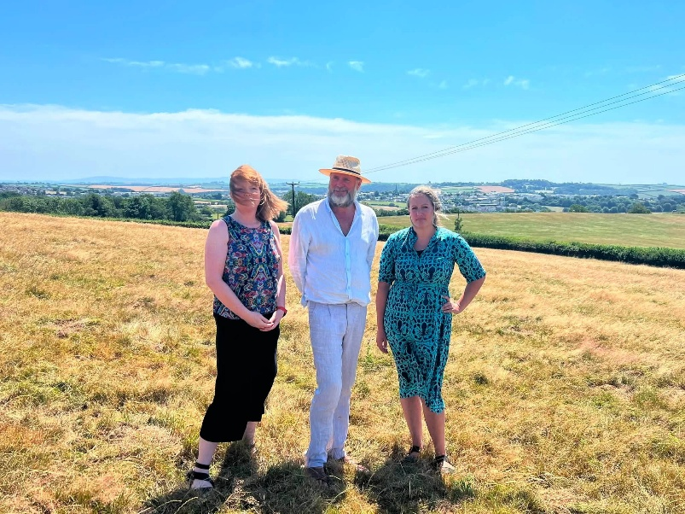
I was delighted to welcome Devon County Council Leader Cllr Julian Brazil and Cabinet Member Cllr Denise Bickley to Great Torrington recently.
As well as visiting the primary school, it was a valuable opportunity to walk part of the public footpath network that leads directly into the centre of the proposed data centre site and to drive around the wider development area, including the proposed 100-acre BESS site.
I would encourage anyone interested in these proposals to visit the area themselves (but make sure you stick to the public footpaths!). Standing within the landscape and seeing the panoramic views stretching from Dartmoor to the North Devon coast provides a valuable perspective on the scale of what is being proposed and why so many local people regard the location as wholly inappropriate.
Local Plan Consultation
A reminder that Torridge and North Devon Councils want to hear from residents, businesses and service providers.
What do you value about living here?
This is your opportunity to influence the future of the place we call home.
The first scoping consultation for the new Local Plan is now open and closes on 11 August 2026.
https://www.torridge.gov.uk/article/22565/Residents-invited-to-help-shape-new-local-plan-for-North-Devon-and-Torridge
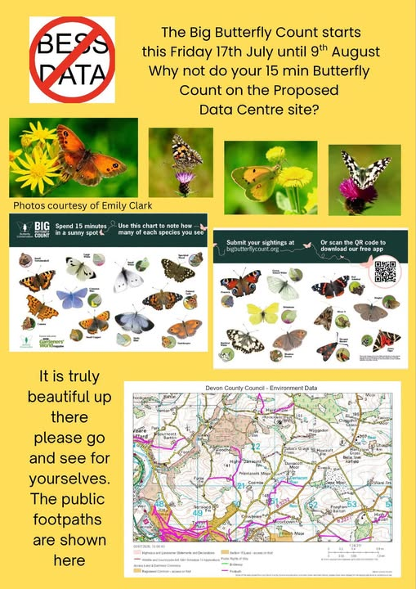
Biodiversity Recording
For anyone taking part in the Big Butterfly Count, please consider using the iNaturalist app to record your observations and locations.
It would also be extremely helpful if residents could use the app to record other wildlife, including bats, birds, insects and other species in and around the proposed data centre and BESS sites.
This information can help build a clearer picture of the biodiversity that exists within the area and could provide useful evidence about the environmental importance of the site.

What You Can Do
I strongly encourage all residents, businesses, farmers, community organisations, town councils and parish councils to make their voices heard.
The decisions currently being discussed, whether through Local Government Reorganisation or the proposed Devon Data Campus and Battery Energy Storage System, have the potential to shape the future of our area for generations to come.
You can help by:
- Taking part in all future consultations and public engagement exercises.
- Responding to the North Devon and Torridge Local Plan consultation before 11 August 2026.
- Attending public meetings and information events when they are announced.
- Encouraging neighbours, friends and family members to engage in the process.
- Recording local wildlife, habitats and biodiversity using the iNaturalist app and participating in initiatives such as the Big Butterfly Count.
- Sharing evidence about the environmental, agricultural, heritage and community value of the area.
- Contacting your local councillors, Member of Parliament and relevant decision-makers to ensure our voices are heard.
- Working constructively together across communities and political boundaries to protect what makes North Devon and Torridge special.
No one cares more about this area than the people who live and work here. If we do not speak up, others will make decisions on our behalf. Whether your concerns relate to the future of local government, the protection of our countryside, the preservation of productive farmland, or the character of our communities, now is the time to become involved.
The proposed Devon Data Campus would be the biggest data centre development in Europe and one of the largest battery storage developments in the world. If approved, it would permanently transform a significant area of rural North Devon. Equally, the decisions being taken through Local Government Reorganisation will have lasting consequences for how services are delivered and how rural communities are represented in the future.
Together, we can ensure that rural Devon is not overlooked and that the interests of our communities are properly represented in the decisions that will shape our future.

